- Start by opening up the Progress Explorer Tool
  - You will see this picture (below) after you open the Progress Explorer Tool.
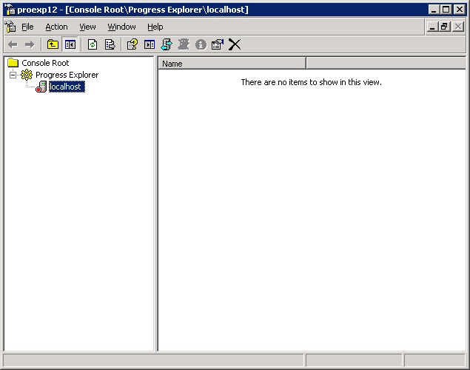

- When you double click on the localhost you get this login box (below).
  - Enter in the username and password
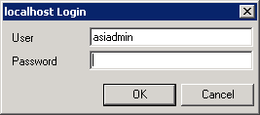

- After you enter in the password you will be the box below.
  - Double click on AppServer and then click on asi.
  - You will stop and start the database that is “Not Running.”
